**IMPLEMENTING SOCIAL NETWORK IN OUR CAMPUS**

**A PROJECT REPORT**

*Submitted by*

**M.DINAKAR**

**R.NAGULAN**

**R.SAKTHIBALAN**

**M.SARAVANAKUMAR**

*in partial fulfillment for the award of the degree*

*of*

**BACHELOR OF ENGINEERING**

In

COMPUTER SCIENCE AND ENGINEERING



**UNIVERSITY COLLEGE OF ENGINEERING, RAMANTHAPURAM**

**ANNA UNIVERSITY::CHENNAI 600 025**

**JUNE 2022**

**ANNAUNIVERSITY::CHENNAI 600025**

**BONAFIDE CERTIFICATE**

Certified that this project report **“IMPLEMENTING SOCIAL NETWORK”** is the bonafide work of **“M.DINAKAR, R.NAGULAN, R.SAKTHIBALAN, M.SARAVANAKUMAR”** who carried out the project work under my supervision.

**SIGNATURE SIGNATURE**

Dr. A. MUTHUMARI M.E., Ph.D., Mrs. K. UMA MAHESWARI M.E.,

**HEAD OF THE DEPARTMET SUPERVISOR**

COMPUTER SCIENCE AND ENGG COMPUTER SCIENCE AND ENGG

UNIVERSITY COLLEGE OF ENGG UNIVERSITY COLLEGE OF ENGG

RAMANATHAPURAM - 623 513 RAMANATHAPURAM – 623 513

Submitted for the Viva-Voce examination held at University College of Engineering, Ramanathapuram on ………….

**INTERNAL EXAMINER EXTERNAL EXAMINER**

## 

## ACKNOWLEDGEMENT

Firstly, we would like to thank the lord almighty for his benevolence and blessings that has given me the strength to complete this project. We express our sincere thanks to our **Dean Dr. J. JEGAN, M.E., Ph.D.,** for providing us with plethora of resources, which enhances the quality of learning.

We express our sincere thanks to **Dr. A. MUTHUMARI, M.E, Ph.D.,** Head of the Department, Department of computer Science and guide for providing necessary facilities to carry out the project work.

We express our sincere thanks to our project coordinator, **Mr. K. MUTHUMARI, M.E(Ph.D).**, Department of Computer Science for providing their valuable suggestions throughtout our project.

We are greatful to all the Teaching and Non-Teaching Staff members of the Computer Science and Engineering Department for their support.

**ABSTRACT**

Android began in 2003 as a project of the American technology company Android Inc., to develop an operating system for digital cameras. In 2004 the project changed to become an operating system for smart phones. Android Inc., was bought by the American search engine company Google Inc., in 2005.

Social network sites (SNSs) are increasingly attracting the attention of academic and industry researchers intrigued by the affordance and reach. This special theme section of the Journal of Computer-Mediated Communication brings together scholarship on these emergent phenomena. In this introductory article, we describe features of SNSs and propose a comprehensive definition. We then present one perspective on the history of such sites, discussing key changes and developments. After briefly summarizing existing scholarship concerning SNSs, we discuss the articles in this special section and conclude with considerations for future research.

**TABLE OF CONTENTS**

|  |  |  |
| --- | --- | --- |
| **CHAPTER NO** | **TITLE** | **PAGE NO** |
|  | **ACKNOWLEDGEMENT** | iii |
|  | **ABSTRACT** | iv |
|  | **LIST OF TABLES** | V |
| **1.** | **INTRODUCTION**  1.1.Overview  1.1.1.Type of Social Media  1.2.Problem Identified  1.3.Need of Social Network  1.4.Scope of the project | **01**  1  1  1  2  2 |
|  |  |  |
| **2.** | **SYSTEM ANALYSIS**  2.1.Existing work  2.2.Proposed work | **03**  03  03 |
|  |  |  |
|  |  |  |
| **3.** | **SYSTEM IMPLEMENTATION**  3.1.Posting Images.  3.2.Library Management.  3.3.Chats Management.  3.4.Online MCQ Test.  3.5. Checking Exam Results.  3.6. News Publish.  3.7.Gathering Notes.  3.8. Programming Tutorials.  3.9.Fun Activity.  3.9.1.Flames  3.10.College Gallery | **04**  04  06  06  07  08  09  10  10  10  11  13 |
| **4.** | **ALGORITHM**  4.1.Algorithm-Send Requests  4.2.Algorithm 2- Library Management  4.3.Algorithm 3- Fun Activity  4.4.Algorithm 4 – MCQ - Test | **14**  14  14  15  15 |
| **5.** | **SOFTWARE DESCRIPTION**  5.1.Java  5.2.Android Studio  5.3.FireBase  5.4.XML | **16**  16  16  17  17 |
| **6.** | **DIAGRAMS**  6.1.Use Case Diagrams  6.1.1.Library Management - Use case  6.1.2.Online MCQ-Test - Use case | 18  18  18  19 |
| **7.** | **CONCLUSION** | **20** |
|  | **APPENDIX**  **REFERENCES** | **21**  **42** |
|  |  |  |

**CHAPTER 1**

**INTRODUCTION**

**1.1. Overview**

Social media refers to the means of interactions among people in which they create, share, and exchange information and ideas in virtual communities an networks. Social media is about conversations, community, connecting with the audience and building relationships. It is not just a broadcast channel or a sales and marketing tool. Social media not only allows you to her what people say about you ,but enables you to respond. Listen first , speak second.

**1.1.1.Types of Social media**

1. Social Networking sites.
2. Social Review sites.
3. Image Sharing sites.
4. Video Hosting sites.
5. Community blogs.
6. Discussion sites.
7. Sharing Economy networks.
   1. **Problems Identified**

Social media is a boon. Or, is it a bane? Though it has its many benefits and uses, there are plenty of social media problems that trouble as. What are these social media issues? And how do we deal with them? One of the major complaints with social media is the amount of time it consumes. Here are some insights into the problems with social media and suggested solutions that may help you use the social media networking sites in the right way.

* 1. **Need of Social Network**

Social networking connects individuals with other people and Education by allowing them to share information, ideas and messages. Some organization also use social network for connect with People.

* 1. **Scope of the Project**

Email security is a term for describing different procedures and techniques for protecting email accounts, content, and communication against unauthorized access, loss or compromise. Email is often used to spread malware, spam and phishing attacks.

**CHAPTER 2**

**SYSTEM ANALYSIS**

**2.1.Existing work**

Here we refer the existing work is a Our College website www.aucermd.edu.in. It Comes under the Community Blog Category .Which is also one type of social media network.

**2.2.Proposed Work**

In the Proposed system Message sending, Invite the friends, Communities, Photo Albums , Online MCQ Test , Library Management and Fun Activities. It Under come the Social Networking.

**CHAPTER 3**

**SYSTEM IMPLEMENTATION**

**3.1.Posting Images**

Option have which is used for uploading Image contend in the Project.

Which like knowledge sharing.

Users create, curate , and share unique images that spark conversation and speak for themselves. A picture can be worth a thousand words to your education.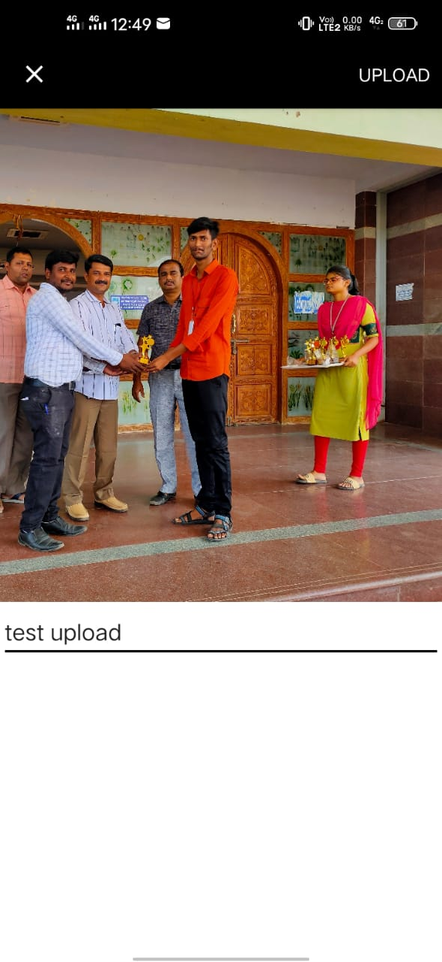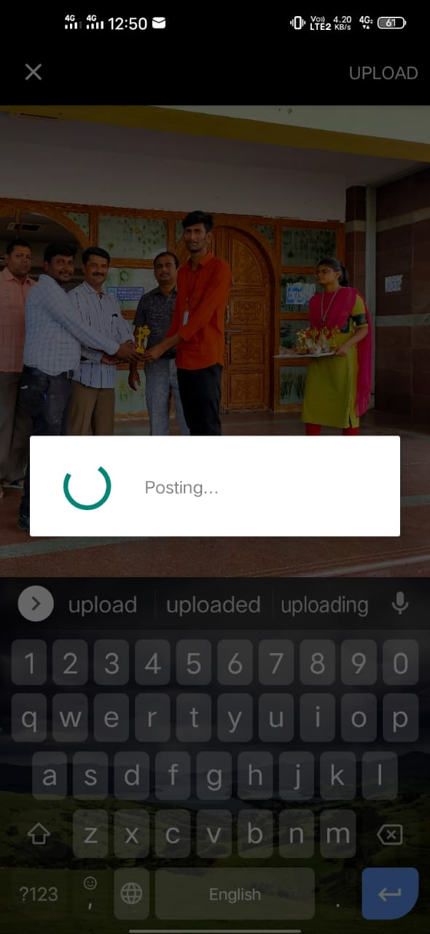

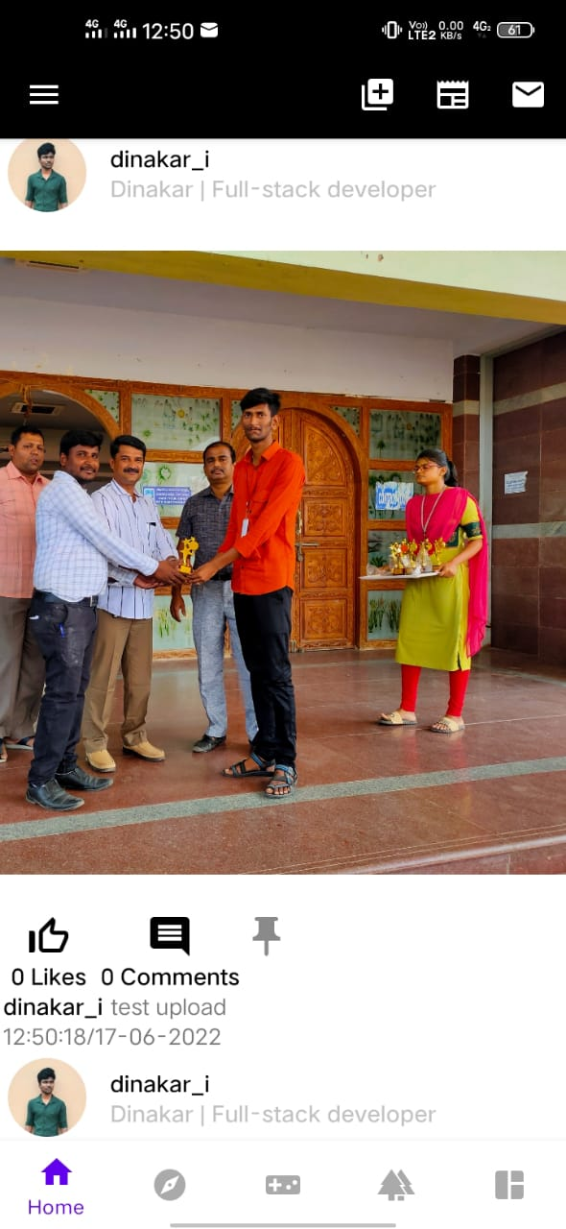

**3.2.Library Management**

Here we using Library E-card for the replacement of Library cards.

1. Any E-Card holder can be able to borrow book from librarian.
2. Each book will have unique identification number other details including a rack number which will help to physically locate the book.
3. There will be two cards for borrowing book.
4. There should be a maximum limit (3) days a member can keep a book.
5. The system should be able collect fines for books returned after the due date.

**3.3.Chat Management**

While most of us have seen many a heated discussion happen on facebook, discussion sites like Reddit and Quora are specifically designed to spark a conversation.

Here Our use what’s app for share information or news. which might distraction could happen our students, Because what’s app not designed for only college purpose many people in their what’s app chats which could be more options to distract students. we solve the problem here, because our project well designed for improve our studies.

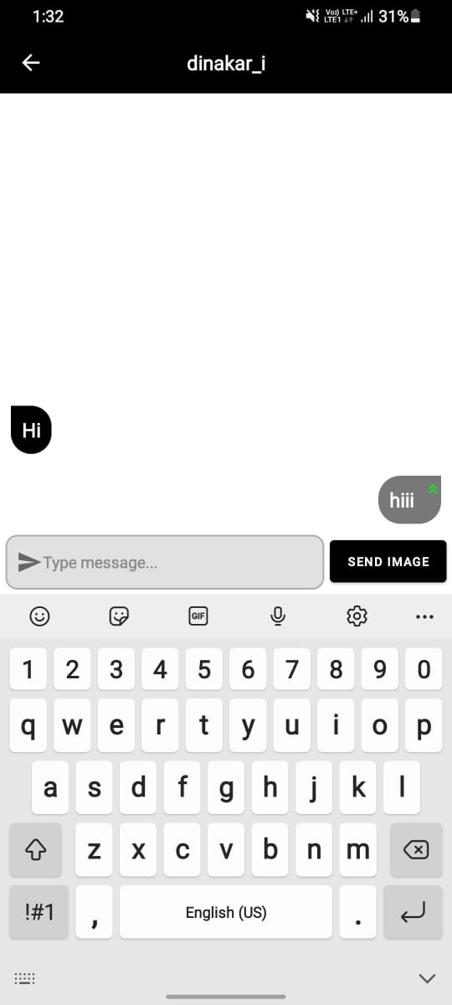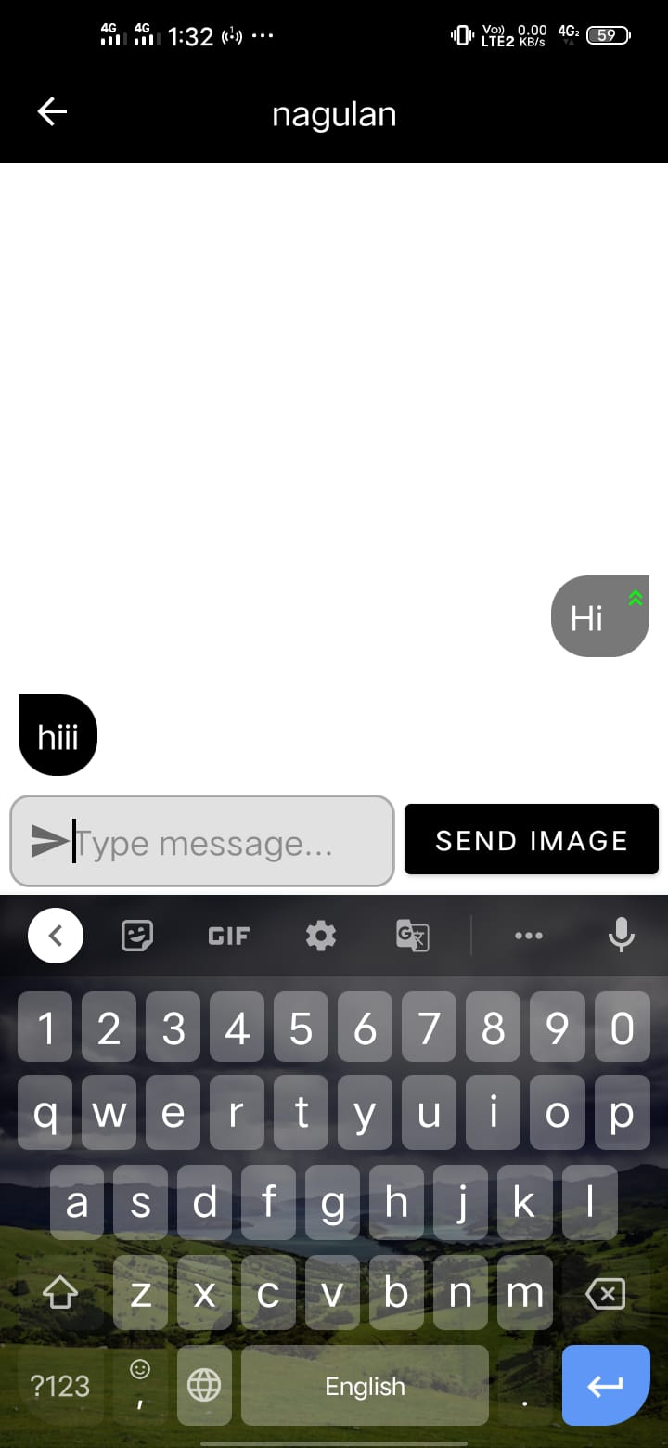

**3.4.Online MCQ-Test**

An online exam is a type of virtual test undertaken on a computer device (desktop, laptop) using the internet. One can give and take an online test from any location remotely.

Online test also known as virtual test, enables Staff to conduct exams using the internet for remote candidates.

**3.5.Checking Exam Results**

Usually we check results on the anna university site. But most of the student forget the website link. Here we solve the problem RSS Feed technology.

Which is used for load web page in android device. In this help of we Load university sites in this app.

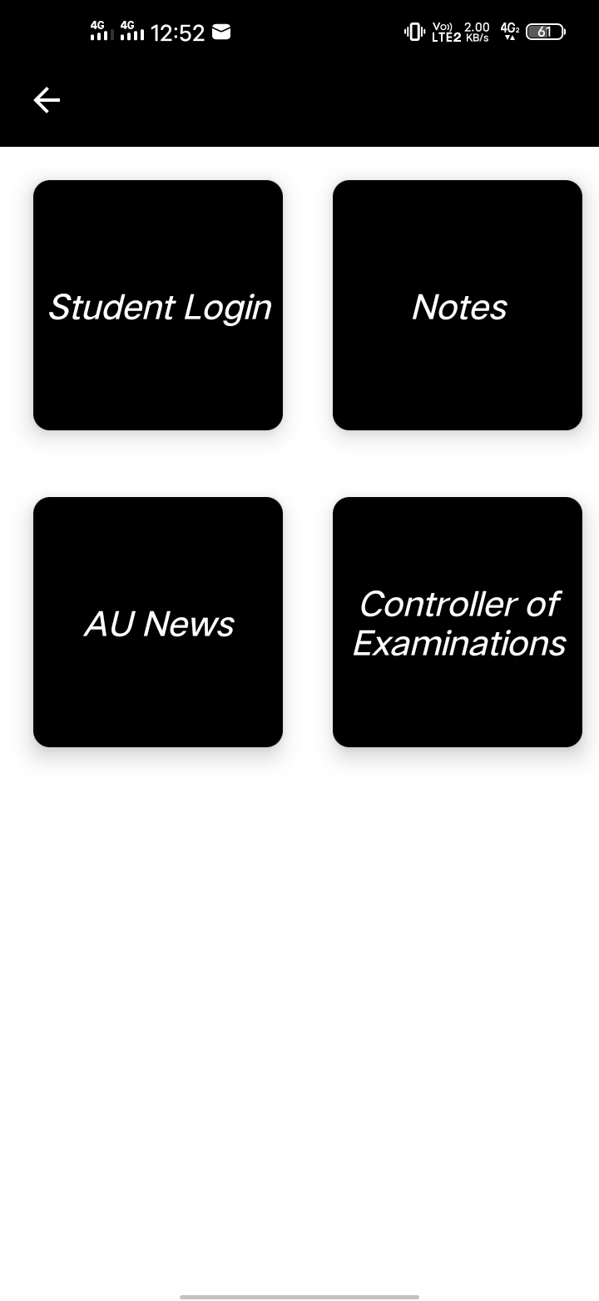

**3.6.News publish**

The staffs can upload the news and can update on the news. When they upload the news it fall on three categories.

1. To staffs:

The news uploaded by the staffs can read by only other staffs and not by students.

1. To students:

The news uploaded by the staffs can be read by students and not by other staffs.

1. To all:

The news uploaded by the staffs can be read by both a staffs and students.

The students can only read the news and they are un able to uploade or make update in the news.

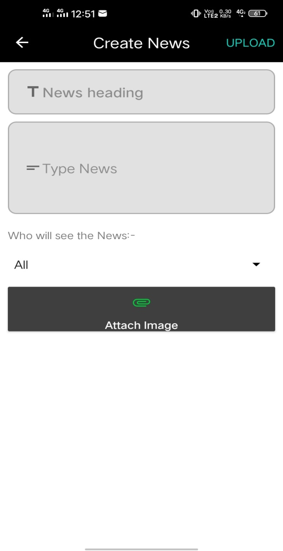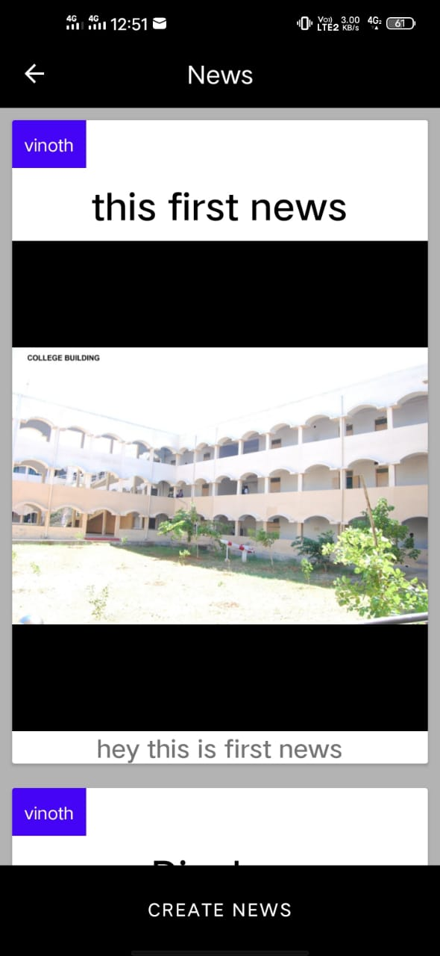

**3.7.Gathering Notes**

1.Notes where uploaded in this app.

2.Students or Staff can view or download the notes.

**3.8.Programming Tutorials**

Programming tutorial videos consist in the app. Student can Study with this tutorials. Conduct MCQ Test related Programming once in a Month.

**3.9.Fun Activity**

Fun activity which mean for Entertainment with fun an logical thinking puzzle games.

**3.9.1.Flames**

We are inserted flames calculator, which is for Make some fun laugh an entertainment.

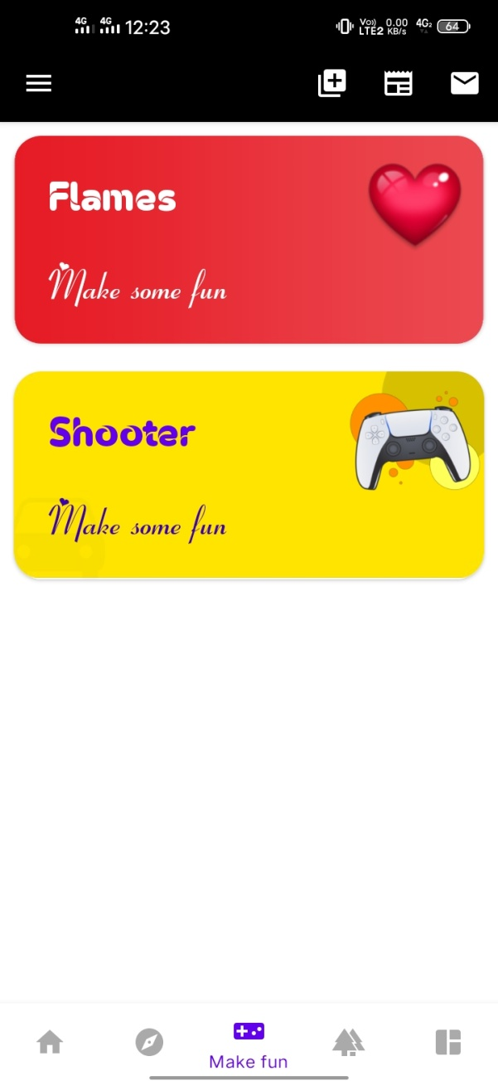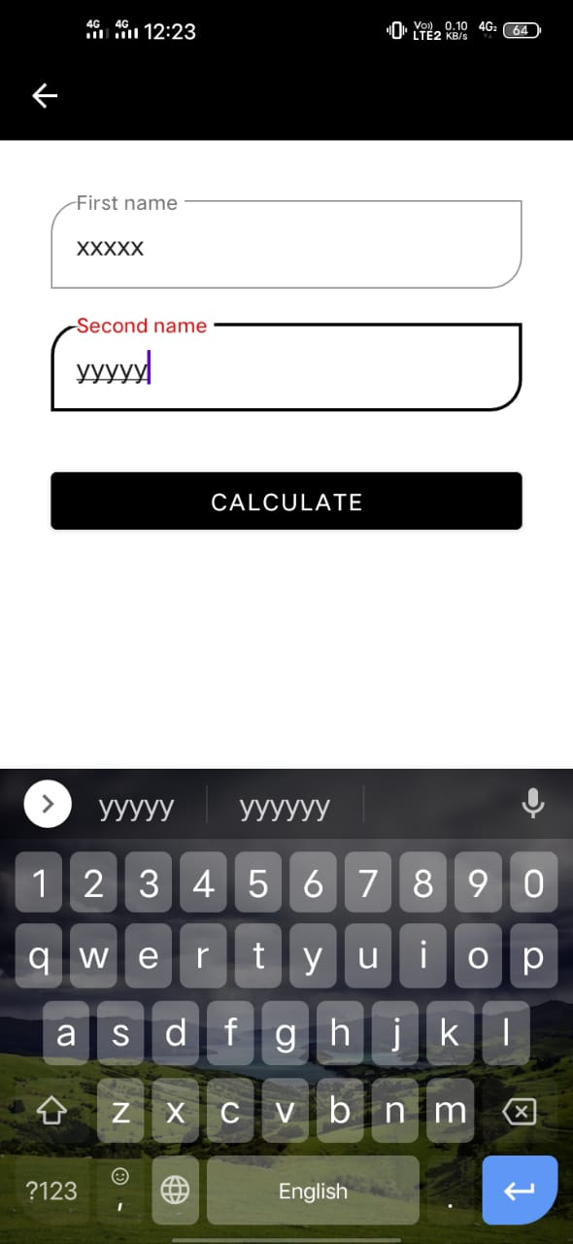

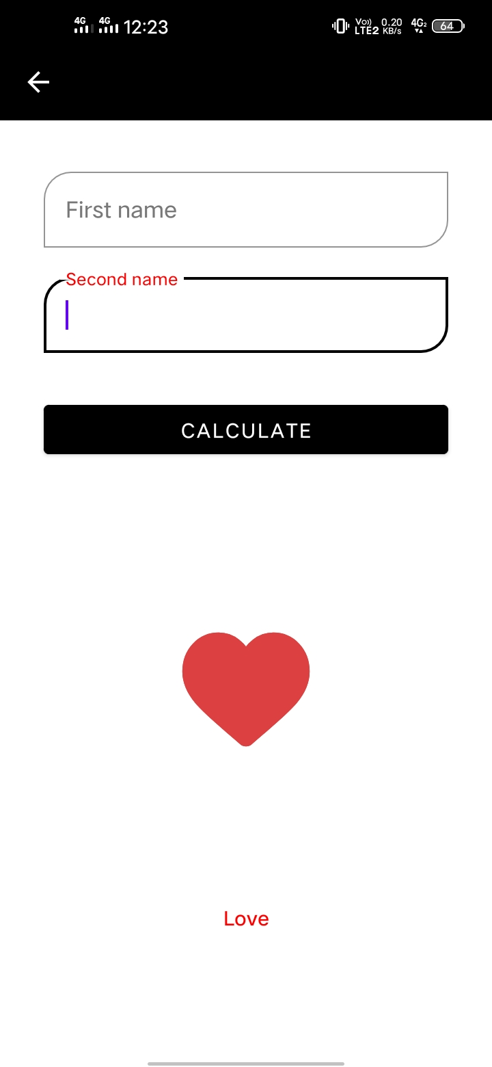

**3.10.College Gallery**

College eventPhotos Store in the Gallery Blog **.**

Users Can see the Photos.

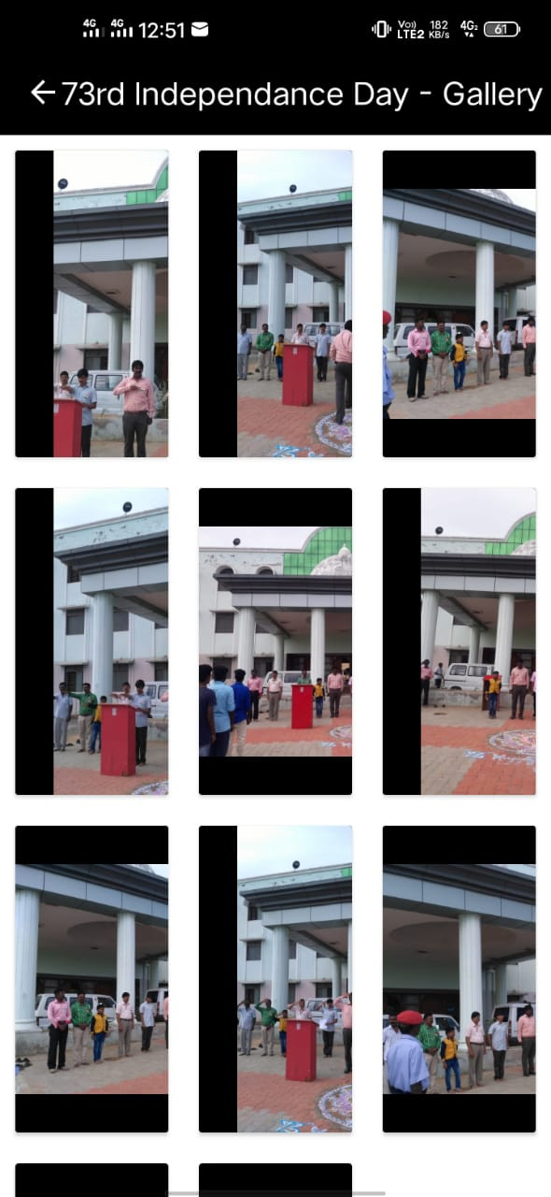

**CHAPTER 4**

**ALGORITHMS**

**4.1.ALGORITHM-Send Requests**

**STEP 1:**START

**STEP 2:**Goto the user profile.

**STEP 3:**Checkwho is coming this profile.

**STEP 4:**If this profile is same user profile set Edit Profile Button.

**STEP 5:**Else the user already a partner remove partner button.

**STEP 6:** User not partner but request to you partner request accept button will visible.

**STEP 7:**User not requested to you at the same time he is not a partner you can send partner Request.

**STEP 8**: END

**4.2.ALGORITHM-Library Management**

**STEP 1:**START

**STEP 2:** If user is a Student have two cards.

**STEP 3:**If student barrowing book from librarian using the cards.

**STEP 4:**Librarian after insert data on the Student card Books no,an Expiry date**.**

**STEP 5:** Missing to submit book due to the date notify to the librarian**.**

**STEP 6:** After pay fine for that.

**STEP 7:**End.

**4.3 ALGORITHM-Fun Activity**

**4.3.1 Flames**

**STEP 1:**START

**STEP 2:**Get two names.

**STEP 3:**Remove the common characters with their respective common occurrences.

**STEP 4:**Get the count of the characters that are left.

**STEP 5:**Take FLAMES letters as Character at Array format [“F”,”L”,”A”,”M”,”E”,”S”].

**STEP 6:**Start removing letter using the count we got.

**STEP 7:**The Letter which last the process is the result**.**

**STEP 8** : END.

**4.4.ALOGORITHM-MCQ-Test**

**STEP 1:** START.

**STEP 2: If user role is Staff can make test.**

**STEP 3: Include register number who attend the test.**

**STEP 4:Display the test campaign include register number.**

**STEP 5: Complete the test.**

**STEP 6 : Text publisher publish the test result.**

**STEP 7:**END.

**CHAPTER 5**

**SOFTWARE DESCRIPTION**

**5.1.Java**

Java was created at Sun Microsystems, Inc., where James Gosling led a team of researchers in an effort to create a new language that would allow consumer electronic devices to communicate with each other. work on the language began in 1991, and before long the team’s focus changed to a new niche, the World Wide Web.

Although it is primarily used for Internet-based applications, Java is a simple, efficient, general-purpose language. Java was originally designed for embedded network applications running on multiple platforms still java run on 2.8 billion active android devices.

**5.2.Android Studio**

Android Studio is the official integrated development environment ([IDE](https://www.techtarget.com/searchsoftwarequality/definition/integrated-development-environment)) for Android application development. It is based on the [IntelliJ IDEA](https://www.theserverside.com/definition/IntellJ-IDEA), a [Java](https://www.theserverside.com/definition/Java) integrated development environment for software, and incorporates its code editing and developer tools.

To support application development within the Android operating system, Android Studio uses a Gradle-based build system, emulator, code templates, and [Github](https://www.techtarget.com/searchitoperations/definition/GitHub) integration. Every project in Android Studio has one or more modalities with source code and resource files. These modalities include Android app modules, Library modules, and Google App Engine modules.

Android Studio uses an Instant Push feature to push code and resource changes to a running application. A code editor assists the developer with writing code and offering code completion, refraction, and analysis. Applications built in Android Studio are then compiled into the [APK format](https://www.techtarget.com/whatis/definition/APK-file-Android-Package-Kit-file-format) for submission to the Google Play Store.

**5.3.FireBase**

Google Firebase is a Google-backed application development software that enables developers to develop iOS, Android and Web apps. Firebase provides tools for tracking analytics, reporting and fixing app crashes, creating marketing and product experiment.

Firebase mostly used for?

Firebase provides detailed documentation and cross-platform SDKs to help you build and ship apps on Android, iOS, the web, C++, and Unity.

**5.4.XML**

Extensible Markup Language (XML) is a markup language used to describe the content and structure of data in a document. It is a simplified version of Standard Generalized Markup Language (SGML). XML is an industry standard for delivering content on the Internet.

XML is a markup language based on Standard Generalized Markup Language (SGML) used for defining markup languages. XML's primary function is to create formats for data that is used to encode information for documentation, database records, transactions and many other types of data.

**CHAPTER 6**

**DIAGRAMS**

**6.1.Use Case Diagrams**

**6.1.1.Library Management – Use case diagram**

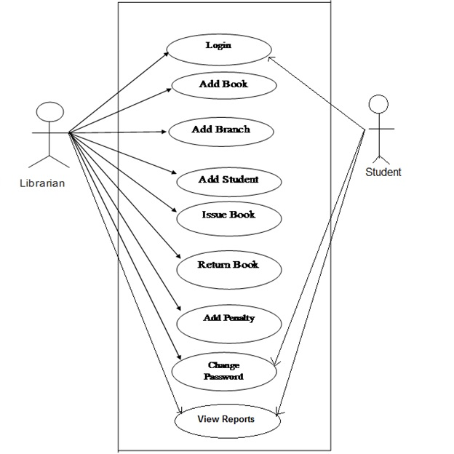

**6.1.2.MCQ-Test – Use case diagram**

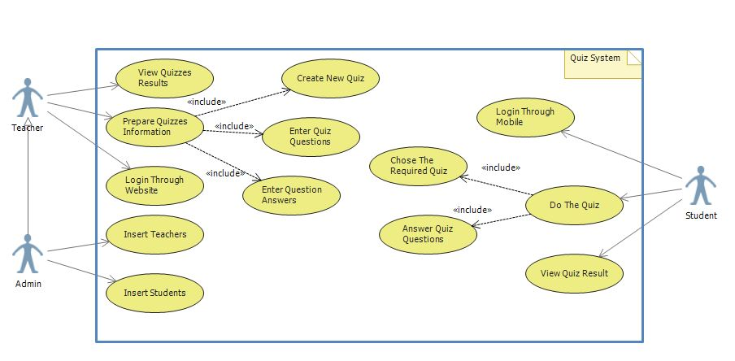

**CHAPTER 7**

**CONCLUSION**

**Social media has taken it’s position into the real world and has interdered with the lives of many. As users log on to their social media profiles, they are begin removed away from the real world and placed into the virtual dimension.**

**APPENDIX**

**Screen Shots**

**Splash Screen:**

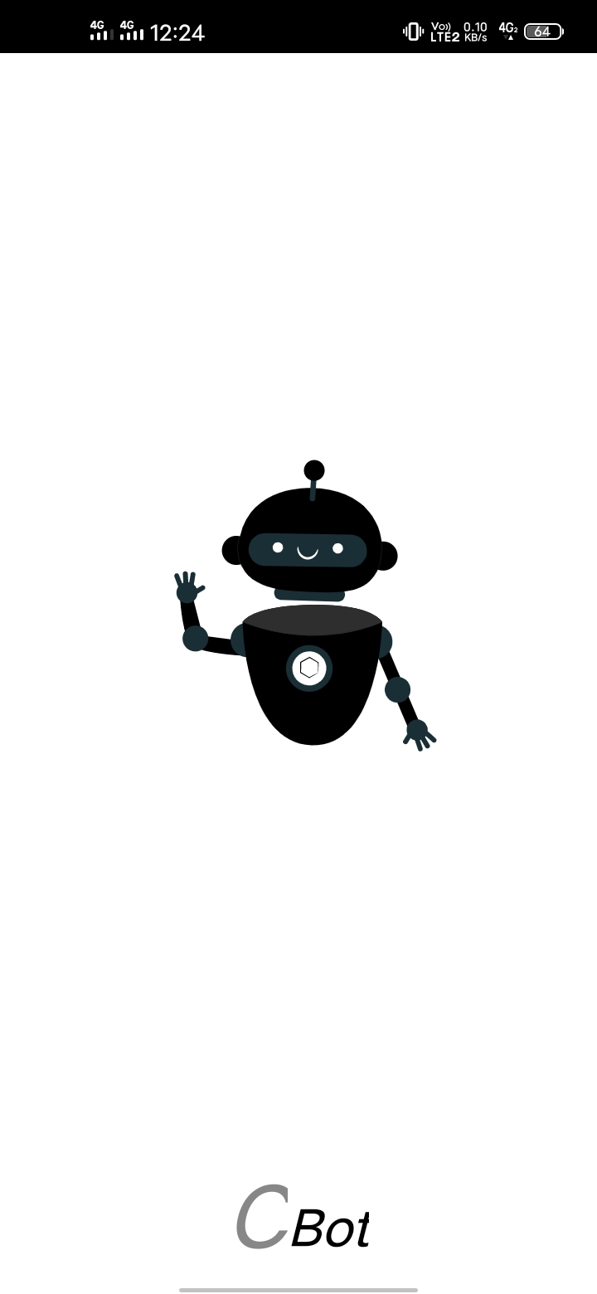

**Sign Up Activity:**

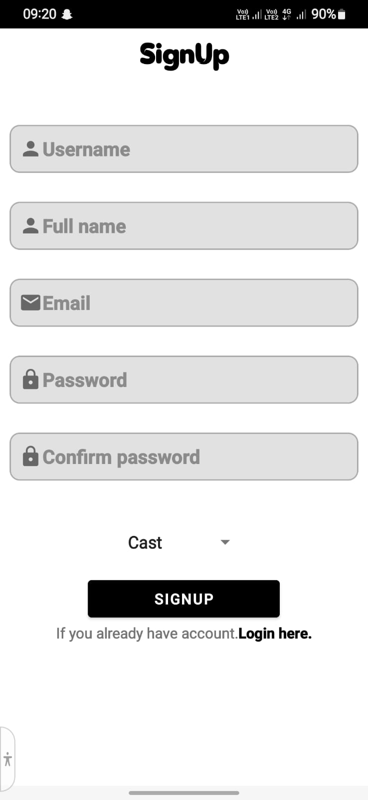

**Login Activity:**

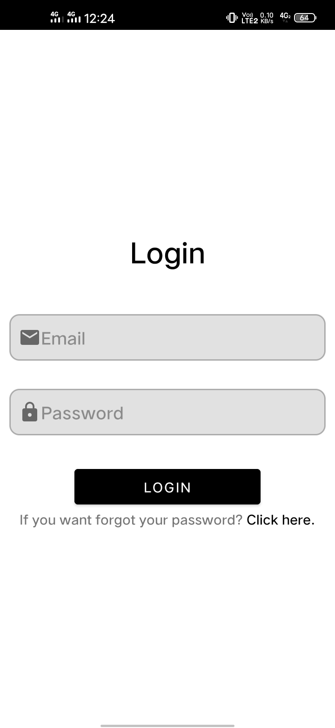

**Home Activity:**



**Posting Images:**





**Search User Activity:**

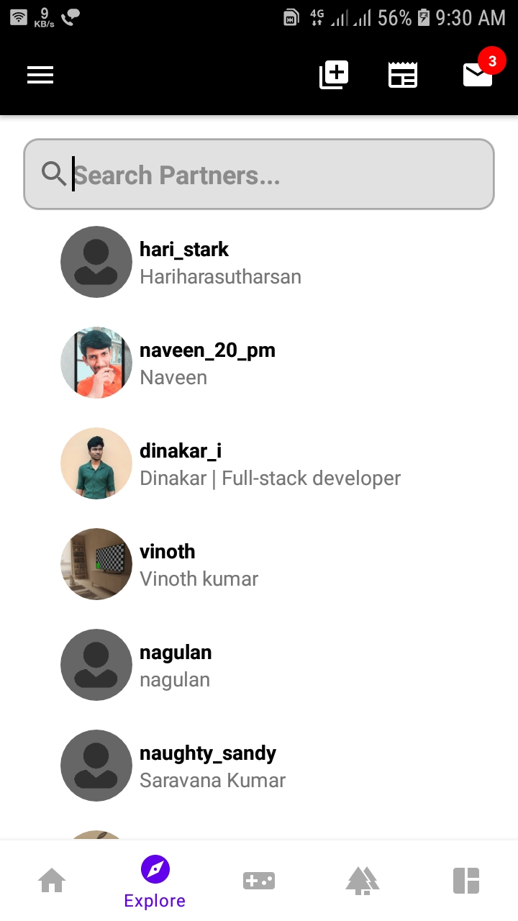**Fun Activity:**

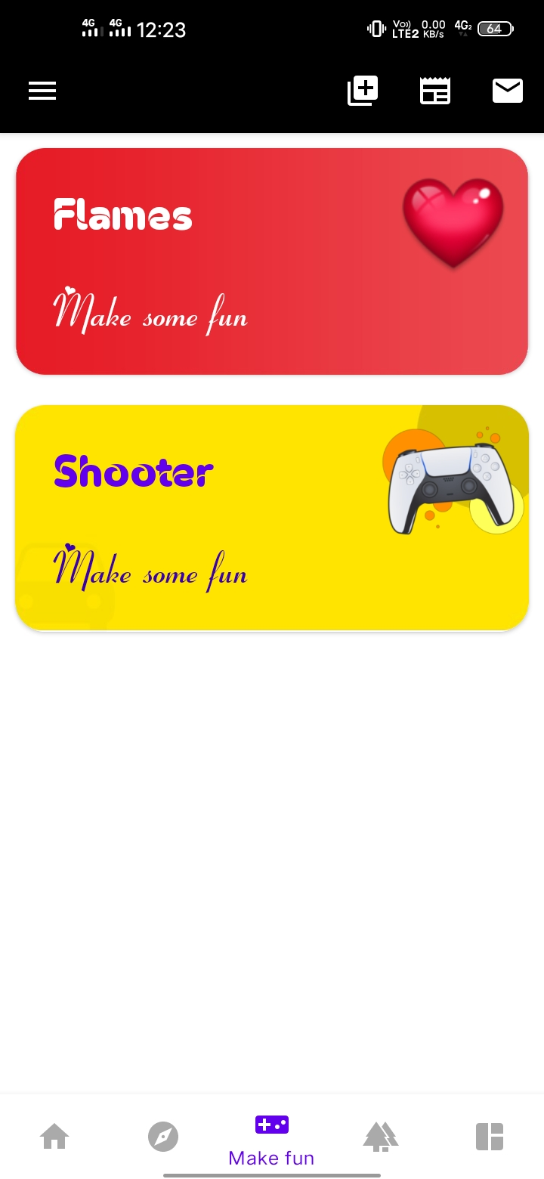



**College Gallery:**

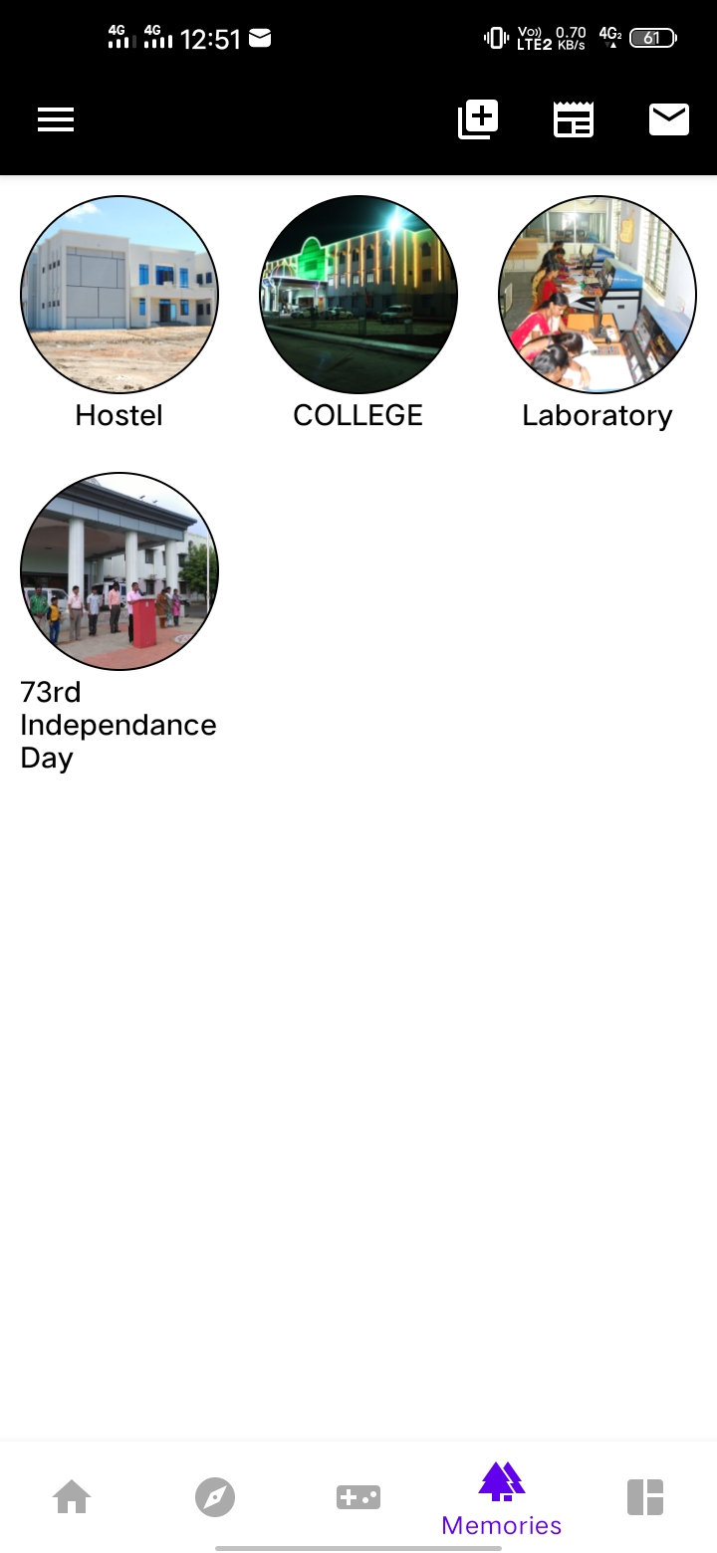

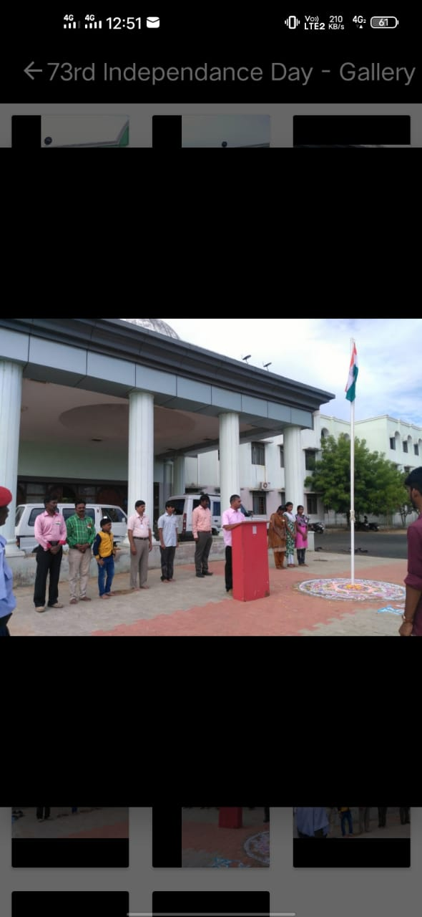

**News Activity:**



**Create News Activity:**

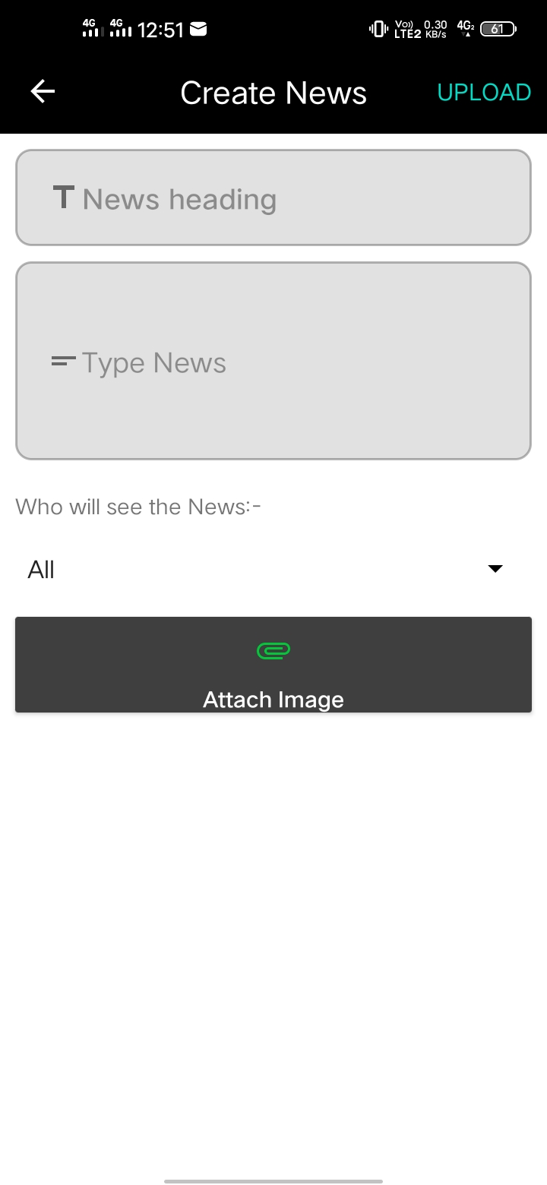**Profile Activity:**

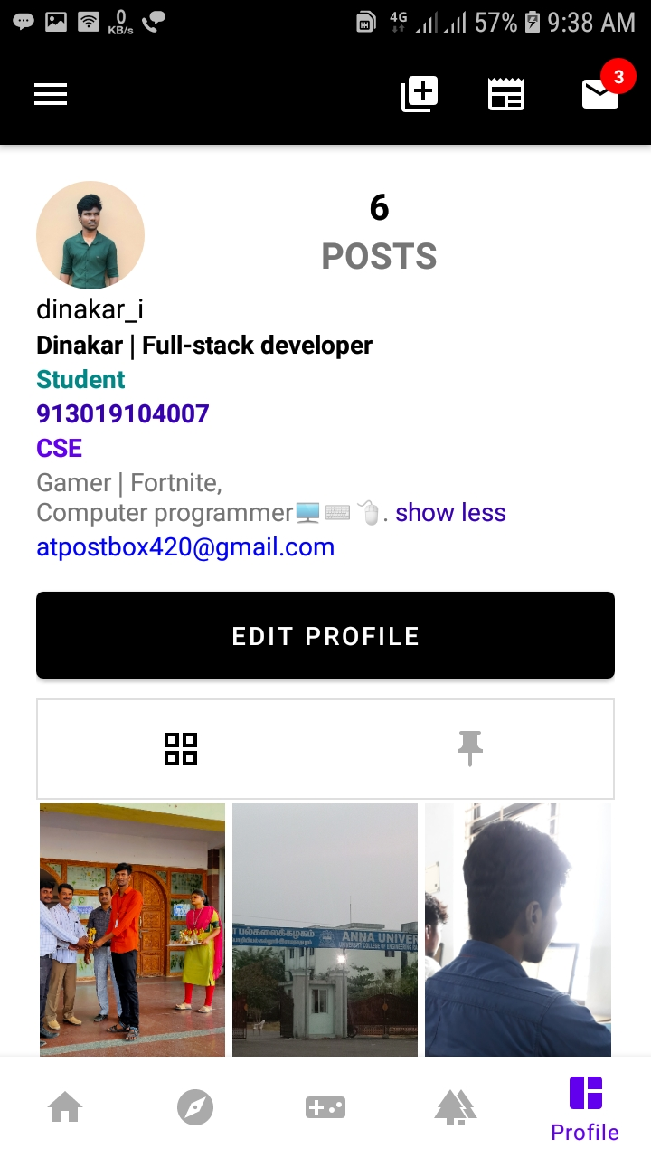

**RSS-Field:**



**Slide Menu:**

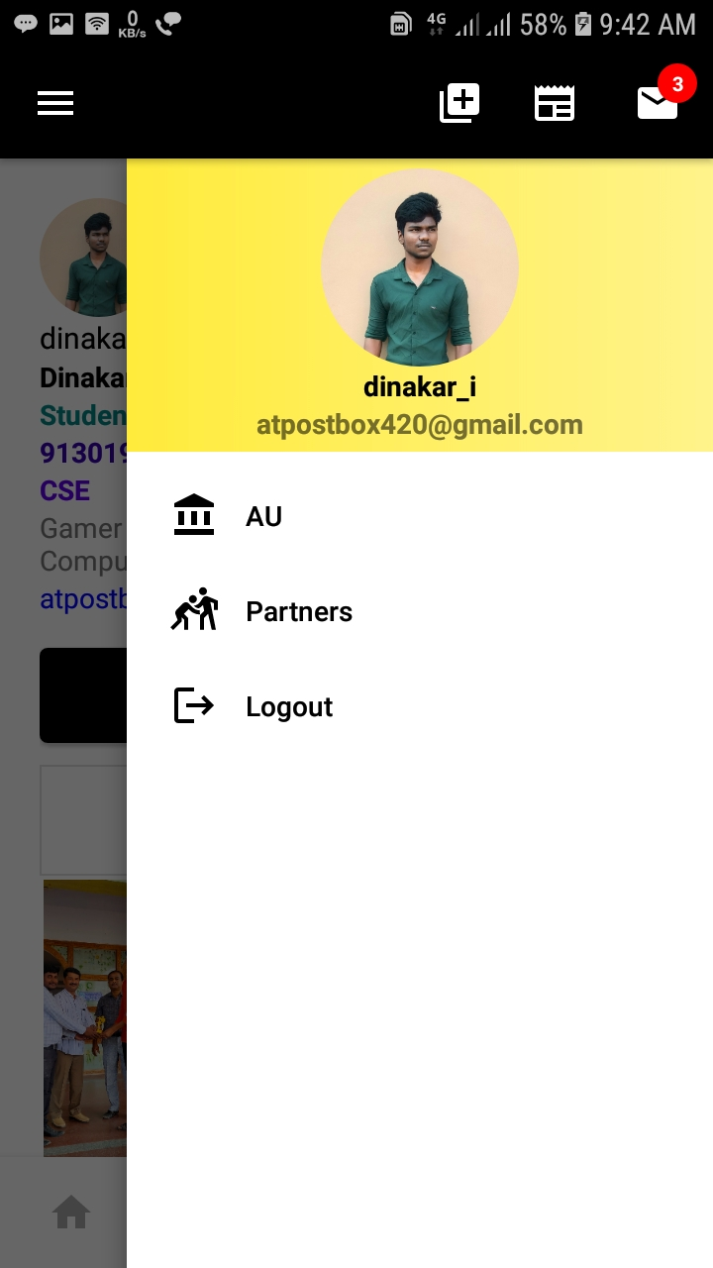

**Chat User Activity:**

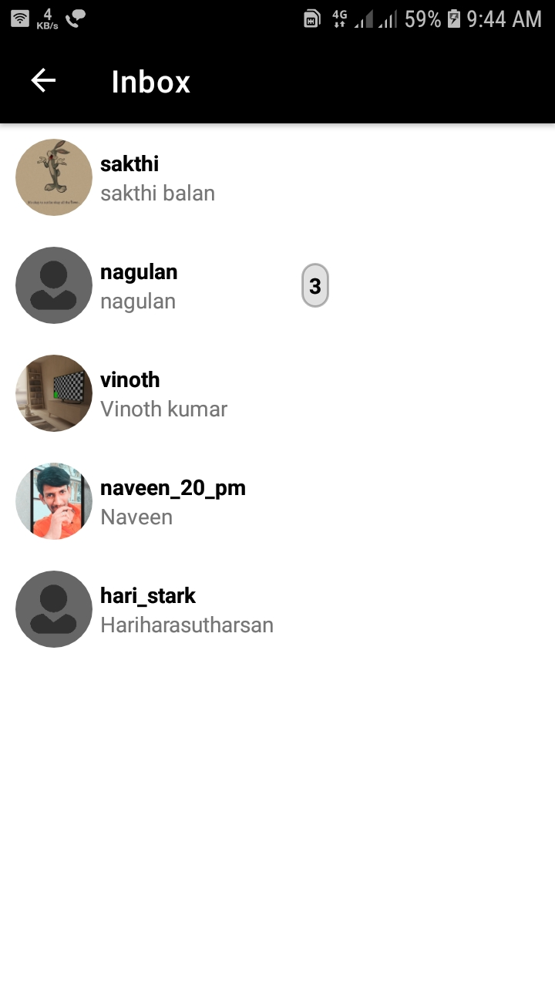





**REFERENCE**

1. Android Programming: The Big Nerd Ranch Guide (Big Nerd Ranch Guides) (By: Bill Philips & Brain Hardy)
2. Reto Meier, “Professional Android Application Development ”,Wiley Publishing Inc.,Indiapolis,Indiana,2009.Google Inc.,Using JSON with Google Data APIs, July 3,2009.